Tutorial

Creating problem files and sets in TINA

The following tutorial takes you step by step through the creation of four problems and a problem set to use in TINA's Training and Examination modes.

1) Creating a selection type problem

Start TINA.

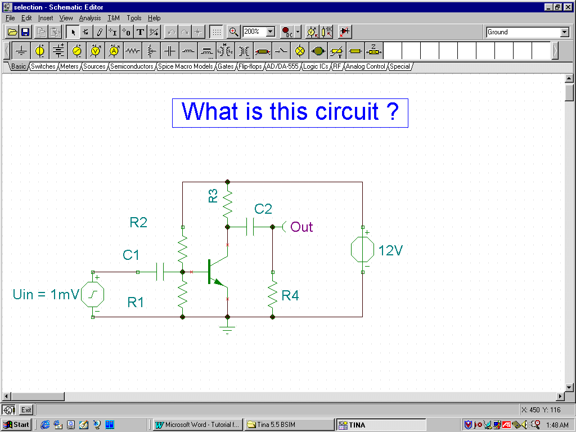
Create or load the circuit below (selection.sch).

Invoke TINA’s Exam Manager via the View menu.
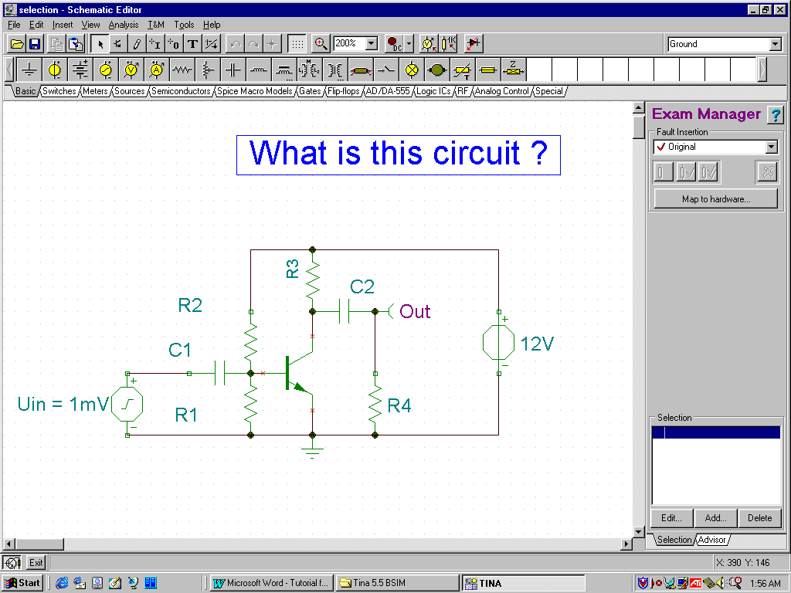
To add an alternative selection, press the Add... button. The selection editor dialog will appear and you can enter the desired text. If this selection is the right answer, check the ‘This is the good answer’ field.

To edit a previous entered selection, press the Edit... button. The same editor dialog will appear.

To delete a previously entered solution, highlight it and press the Delete button.

After adding three alternatives you should see the following screen:

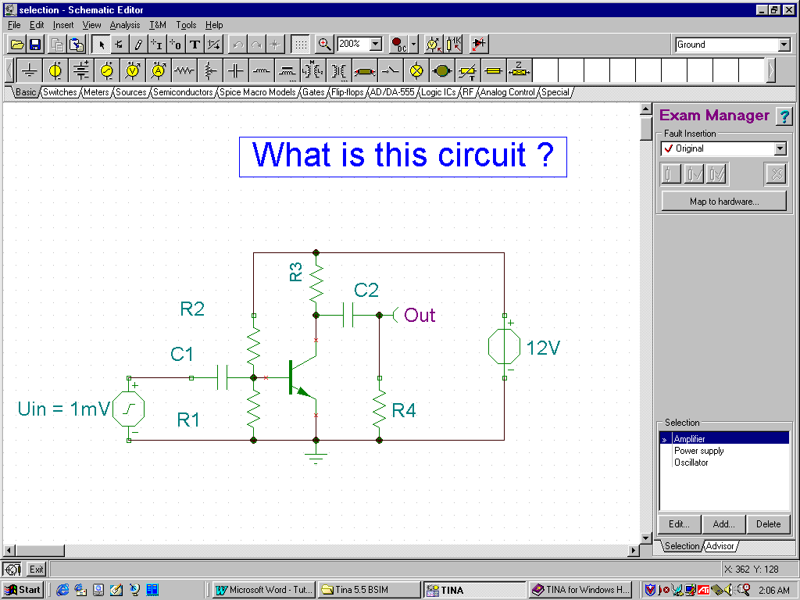

By using the advice (hint) management panel, you can enhance the problem by adding hints for the student . If you incorporate hints, you may want to assign a penalty to the use of the hint. By asking for a hint with a penalty, the student accepts a reduction of the maximum possible score. Scores and penalties are both measured in percent.

The upper right corner of the advice manager displays the number of the current advice and the total number of advices. You can move among the advices with the left and right arrows. The order of advices is important: this is the only order in which the student will be able to access them in the Exam Manager.

To add a new advice at the end of the advice list, select the Advisor tab and then press the Add button. The advice editor dialog will appear. You can enter the advice and the penalty (in percent).

To insert a new advice before the current advice, press the Insert button. The advice editor dialog will appear.

To delete the current advice, press the Delete button.

To edit the current advice, press the Edit button.

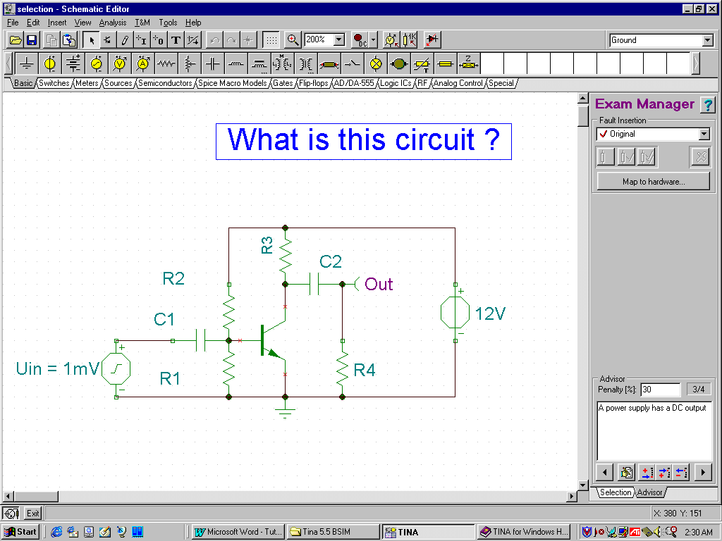

Finally, save the selection.sch file in the predefined folder called TEST under TINA’s main folder.

2) Creating a DC problem

Create or load the circuit below (DCproblem.sch).

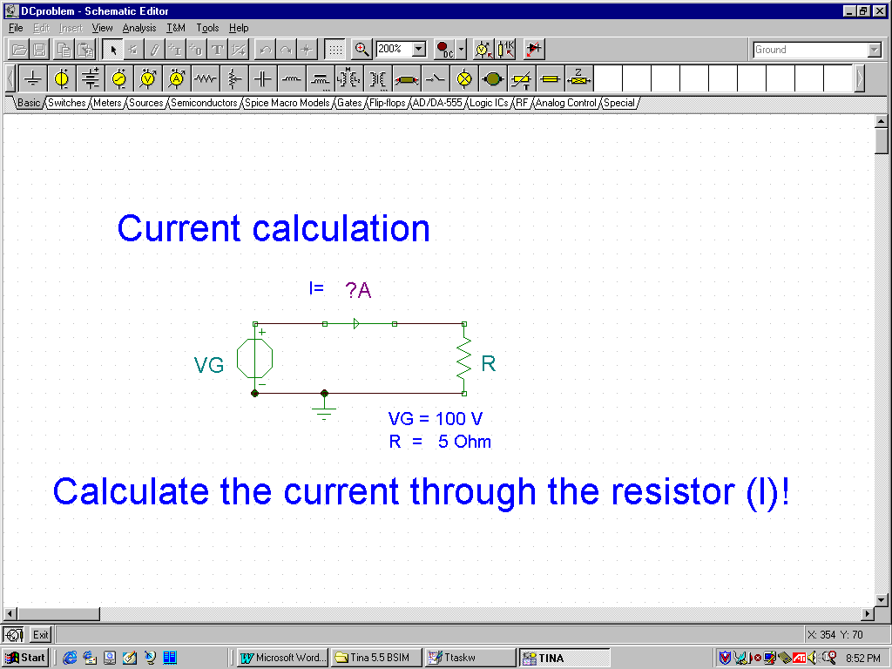

Note that the circuit contains a Current Arrow to indicate the circuit variable whose value is to be found. (You could also use an Ammeter.) In general, every DC problem should have one and only one instrument for the unknown quantity. In TINA's Training and Examination modes, instruments placed in the circuit will not show the measured value, but instead will ask the student for its value.

You can add hints to the problem (as described above for selection problems). When done, save it in TINA's TEST folder.

3) Creating an AC problem

AC problems are very similar to DC problems, but of course will contain sinusoidal excitation and reactive components. In Training and Examination modes, the program will ask for the magnitude and phase of the value indicated by the instrument. As an example, create or load ACproblem.sch shown below, or a similar problem, in TINA's TEST folder.

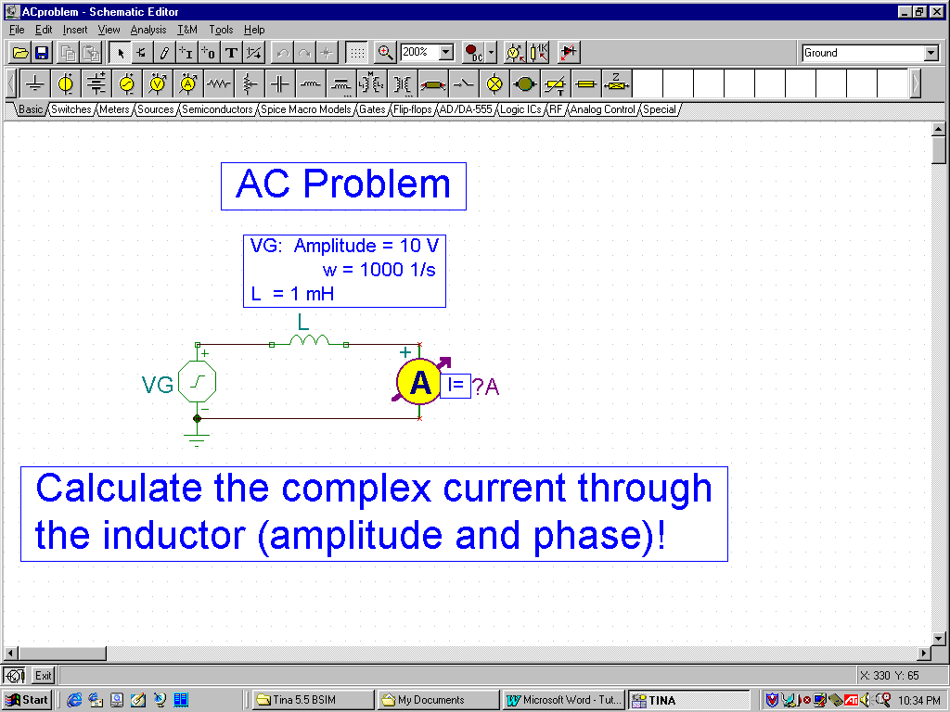

4) Creating a troubleshooting problem

Create or load the circuit below (DCtroubleshooting.sch), and invoke the Exam Manager from the View menu.

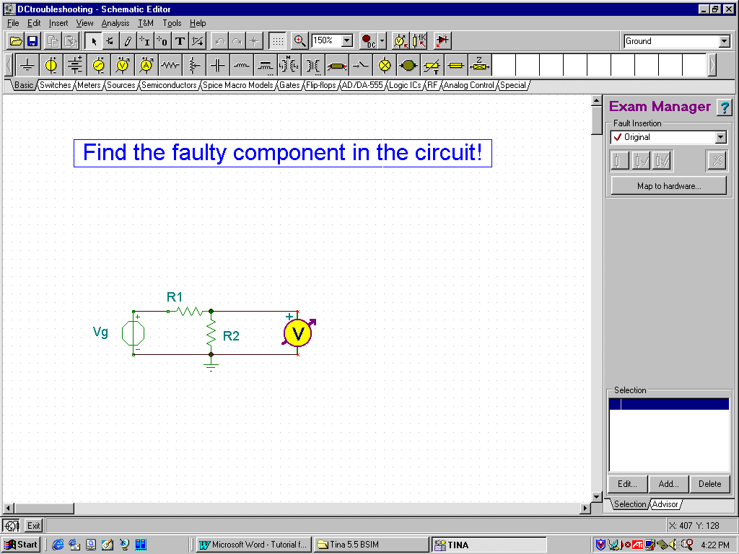

Using the listbox (displaying "Original" at the top), create a new version of the circuit on the top of the exam manager. Note that if you just load the existing DCtroubleshoot.sch file, Version #1 will already exist. Now you can insert faults in any component using the left-most button below the version listbox. Press the button, and the cursor will change into a screwdriver symbol. Move this cursor over the required component (R1 in our example) and click on it. The Property window of the component will appear. Scroll the property window downward until you see the Fault line. Now click the left field of this line. A small listbox will appear where you can select from the allowed faults for this component. For our example, select Open (open circuited component).

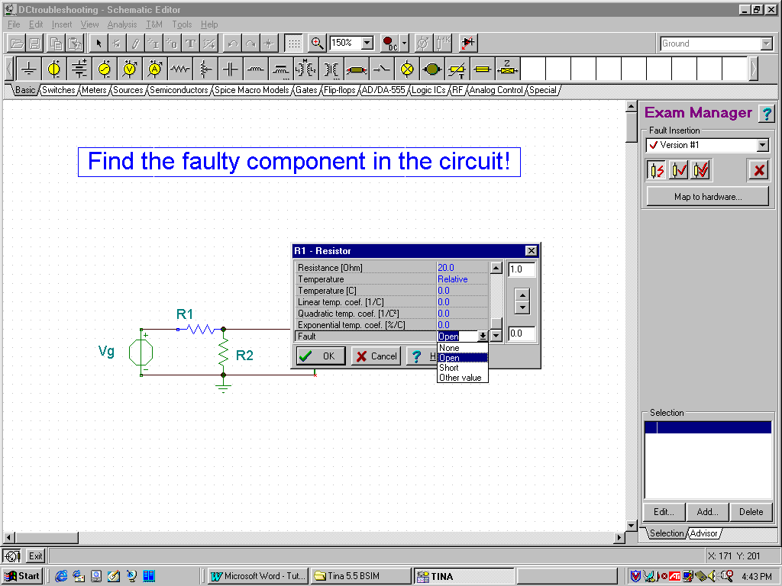

Press OK on the Property box. You have inserted a fault in this circuit. You can continue making other versions of the circuit with different faults. TINA will present these alternative versions randomly in the Training and Examination modes (but see below).

Finally, using the listbox at the top of the Exam Manager, switch back to the Original version and save the circuit as DCtroubleshoot.sch in the TEST folder.

5) Assembling problem sets for the Training and Examination mode of TINA

In order to use problem files in TINA's Training and Examination mode, they must be collected into problem sets. In Training and Examination mode, TINA will load one problem set at a time. The student is free to select and solve problems from the loaded set.

Let’s collect the four problems created above into a new problem set.

Start the Task List Editor from the TINA folder.

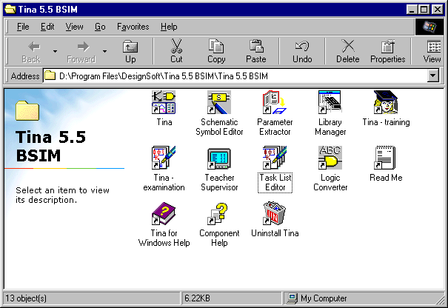

The following window will appear:

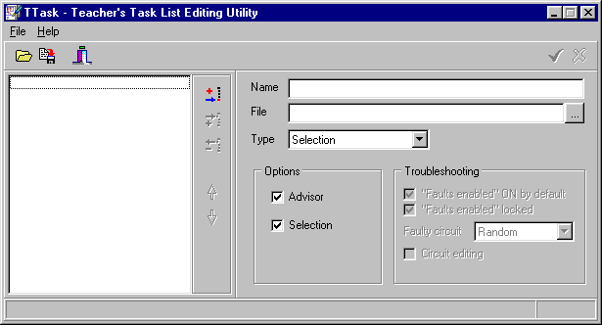

Press the Add Task button just left of the Name field. The default name of the first task will appear.
Change that name to <What is this circuit?> (Note that the left and right arrows will not appear when the problem set is used.)

Press the … button next to the File field and select test\selection.sch

Leave problem Type set to Selection.

Leave the Selection checkbox checked.

You have added the first task.

Press the Add Task button again.

Change the name of the task to DC Problem and select the file test\DCproblem.

Set Type to DC problem.

Uncheck the Selection checkbox.

Change the name of the task to AC Problem and select the file to test\ACproblem.

Set Type to AC problem.

Uncheck the Selection checkbox.

Now add the last problem, a troubleshooting type problem, to this set.

Press the Add Task button again.

Change the name of the task to Troubleshooting and select the file test\DCtroubleshooting.

Set Type to Troubleshooting.

Uncheck the Selection checkbox.

Using other troubleshooting parameters:

Faults enabled “ON” by default: Any faults placed in components are enabled in TINA in the Training and Examination modes.

Faults enabled locked: If checked, the student cannot disable faults. If not checked, the student can disable them using the Analysis/Faults Enabled menu item.

Faulty circuit: If you select Random, the program will randomly select from the circuit versions Otherwise, you must select a circuit version (e.g., version # 1), and this version will be used in the Training and Examination modes.

Circuit Editing: If checked, the circuit can be edited in the Training and Examination modes.

Finally, save the problem set in TINA's test folder as tutorial.exa.

To verify this problem set, restart TINA using the TINA Training or TINA Examination icons in the TINA folder and load tutorial.exa. The problem set will appear.

Let’s run through the problems to confirm their accuracy.

1) If you doubleclick on the first task, the following screen will appear.

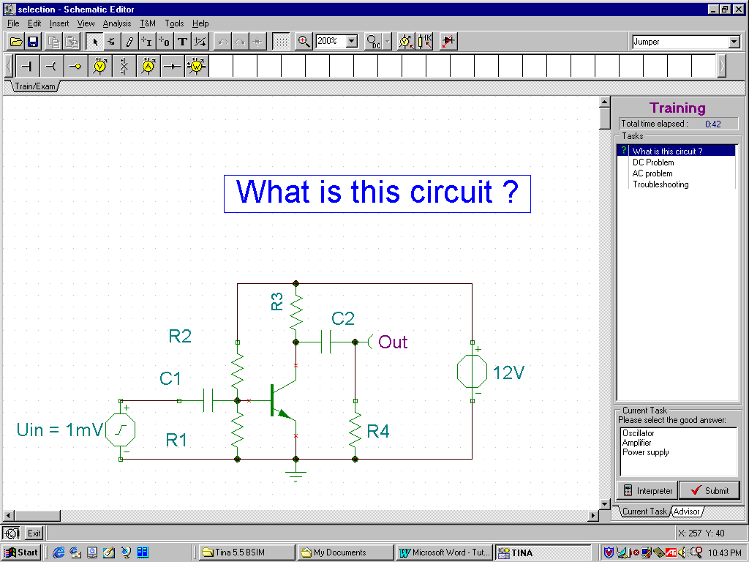

Select "Amplifier" from the list of alternative solutions and press the Submit button.

2) Doubleclick on DC Problem.

Enter 20 or VG/R into the left field and A into the right field of Result: and press Submit.

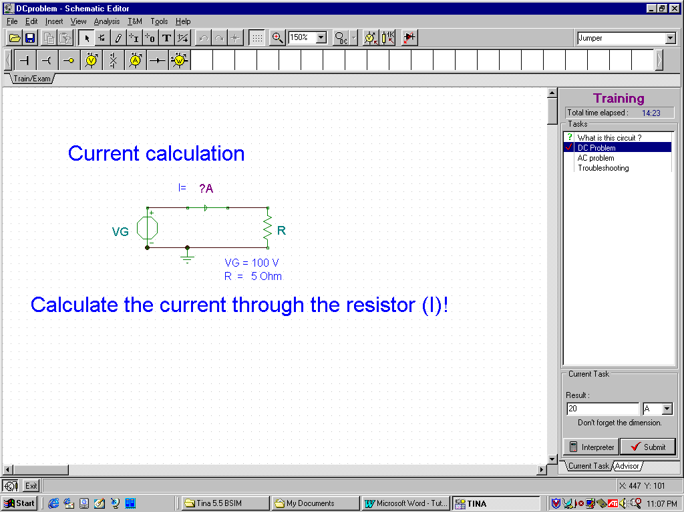
3) Doubleclick on AC Problem.

To give the magnitude part of the answer, enter 10 in the value field and select or enter A into the unit field. To give the phase part of the answer, enter -90 and Deg into the appropriate Phase fields. Press Submit.

4) Doubleclick on the problem "Troubleshooting."

Press one of the buttons with the screwdriver icons, move over R1 with the screwdriver, click, and press Submit.

Now that you have verified all the problems, select File/Exit and answer Yes in the “Exit Exam Session” dialog box.

Finally, let’s use the Teacher Supervisor program to check your performance.

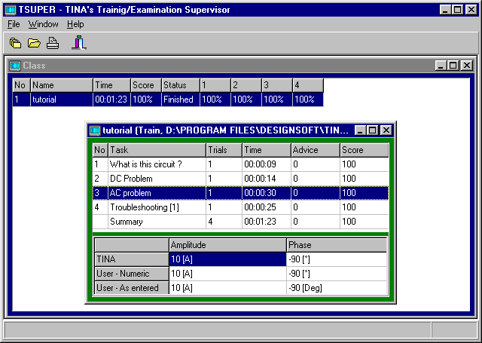

Note that with the Teacher-Supervisor program you can follow the whole class as it proceeds with the solution of a problem set. You can also supervise the problem solving efforts of all users in a network environment.

